**SMFI AND MSI DOCUMENTATION**

**August 2023**

**Contents**

1 Introduction 1

2 Image Capture 1

2.1 Camera board 1

2.2 LED board 1

2.3 LED Driver 2

2.4 Camera Code 3

3 References 3

# Introduction

This document serves as the main documentation for the system develop during the 2022-23 academic year as the “Talking to plants” team project and the continuation of this work over the summer of 2023 – by Samuel Ryder and David Mohammadi. The system has been split up by subsystem – e.g., image capture, and gateway –, where both hardware and software are documented.

Currently two modes of operation exist for the device – MSI and SMFI. In SMFI mode one group of LEDs is sinusoidally modulated and a set number of images captured during one period. During MSI a single image is taken for each set of LEDs – 16 channels currently implemented.

# Image Capture

## Camera board

For this system the OpenMV H7 [1] is utilised, a global shutter module is also installed on this [2]. Further modifications are made to the camera: the included filter has been removed and replaced with an external filter [3].

## LED board

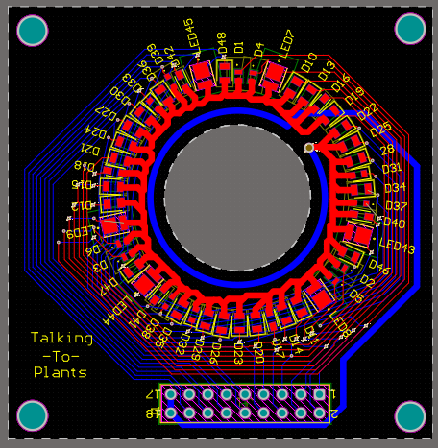

Figure , LED Board

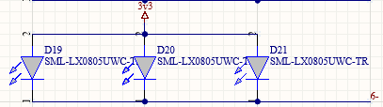

Figure , LED Channel connections

Figure 1 shows the current configuration of the LED board, here 16 channels of 3 LEDs (48 in total) are connected. The LEDs within each channel are connected as shown in Figure 2. The wavelengths and chosen LEDs for each channel are listed in Table 1 below,

Table , LED Channels

|  |  |  |
| --- | --- | --- |
| **Channel No.** | **Wavelength** | **LED** |
| 0 |  |  |
| 1 |  |  |
| 2 (SMFI) |  |  |
| 3 |  |  |
| 4 |  |  |
| 5 |  |  |
| 6 |  |  |
| 7 |  |  |
| 8 |  |  |
| 9 |  |  |
| 10 |  |  |
| 11 |  |  |
| 12 |  |  |
| 13 |  |  |
| 14 |  |  |
| 15 |  |  |

The LED board PCB and schematic are given in [4].

## LED Driver

The LED Driver serves to take the signals output from the camera and drive the LEDs, as well as this it serves as a connection between the camera and base box. The PCBs for this are given in [5].

The operation of driving the LEDs is explained below,

* The camera selects the appropriate output from the 1-to-16 multiplexer, where each output corresponds to one channel
* The camera output is set to a predetermined level
* A current driver is powered by this
* Current is sank through this via a header connecting to the LEDs

All channels – bar Channel 2 – show the same configuration, an LED driver connected to an output of the 1-to-16 multiplexer and the LED board header. Channel 2 is configured differently as this channel has the option of either being used in MSI or SMFI mode. Here after the 1-to-16 multiplexer output another multiplexer is found, this is a 1-to-2 multiplexer that allows either for an LED driver to be used (MSI), or a transistor (SMFI).

## Camera Code

Two versions of camera code are provided in [6], SMFI and SMFI_MSI. Both operate in the same functionality, however, SMFI is used with the old hardware and SMFI_MSI with the new. Also, as can be seen from the names one is just SMFI and the other both modes. For sake of compactness only SMFI_MSI will be detailed here.

The basic operation of the code can be thought of as below,

* Setup is performed
* When an image capture is triggered, whether by button or timer, execute the main loop of code
* Set the multiplexers selects to match the desired operation
* Output the LED values
* Capture images
* Transmit images
* Perform more captures if required, or, update run parameters from cloud

The individual sections of code are described more thoroughly below.

# References

[1] - <https://openmv.io/products/openmv-cam-h7>

[2] - <https://openmv.io/products/global-shutter-camera-module>

[3] - <https://www.chroma.com/products/parts/at690-50m>

[4] - <https://github.com/SamRyder/Talking-to-Plants-Summer-Work/tree/main/PCB/LED%20Board>

[5] - <https://github.com/SamRyder/Talking-to-Plants-Summer-Work/tree/main/PCB/LED%20Driver>

[6] - <https://github.com/SamRyder/Talking-to-Plants-Summer-Work/tree/main/Code/Open%20MV%20Camera/Production_CODE>